Borrowed from 1992 ACM East-Central Regional problem set

BAD TO THE BONE
Consider a standard set of double-six dominoes with each piece in the set (each bone) as shown below:
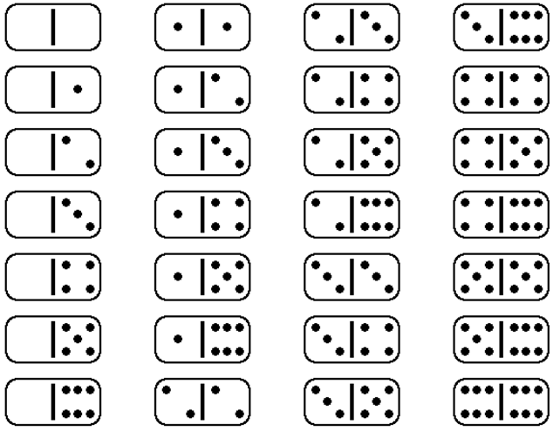

Note that the Dominos may appear in either of two orientations. That is, the Dominos may be rotated 180 degrees.

You have been given the completed Domino class listed on the next page which represents a single domino.

/**
* Domino.
*/
public class Domino {
// instance variables
private int left;
private int right;

/**
* Constructor for objects of class Domino
*/
public Domino(int l, int r) {
left = l;
right = r;
}

public int getLeft() { return left; }

public int getRight() { return right; }

public boolean equals(Object obj) {
Domino temp = (Domino) obj;
return getRight() == temp.getRight()
&& getLeft() == temp.getLeft();
}

public String toString() {
return "[" + getLeft() + ", " + getRight() + "]";
}
}
You may add any methods to this class you desire, but you must NOT alter the existing methods.

The following sample code is used to represent its corresponding domino.

new Domino (2, 5) | 
new Domino (0, 3) | 
new Domino (3, 0) | 

Note that the last two Dominos represent the same Domino in both its orientation. A sample code fragment is included to help clarify the Domino class.

Domino d1 = new Domino(0, 3);
d1.getLeft() returns 0;
d1.getRight() returns 3;
and
Domino d2 = new Domino(2, 5);
d2.getLeft() returns 2;
d2.getRight() returns 5;

A popular diversion among domino players involves laying several of the bones from the set (selected at random) end-to-end, and then eliminating adjacent pairs of dominoes (from left to right) which touch at the same pip value. Consider the example with six dominoes shown below.
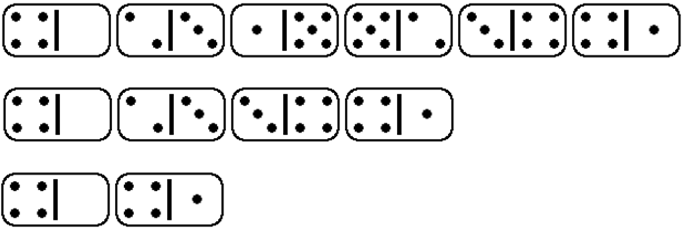
The original draw resulted in these six dominoes. Note that when each domino is aligned, it may appear in either its forward or its backward orientation (the table above shows the forward orientations of all non-doubles). Play begins from the left end and returns to the left end after any pair of dominoes is eliminated. In this case, domino (1, 5) and domino (5, 2) are eliminated from the row since they touch each other with 5 pips. The row is collapsed and play begins again at the left end. This time, domino (2, 3) and (3, 5) are eliminated since they touch each other with 3 pips. The row is again collapsed. Since no further eliminations can be made, the game ends. Note that dominoes (4, 0) and (4, 1) cannot be eliminated since their touching edges do not match.

You have been given the incomplete BadToTheBone class. The BadToTheBone constructor has an ArrayList<Domino> as its only parameter which represents the draw to be played. You are to complete the methods containsMatchingEdges and processDraw(). The containsMatchingEdges returns true only if the Domino draw contains two Dominoes with matching edges and returns false otherwise. The processDraw() method eliminates all Dominos from ArrayList<Domino> according the rules described above. That is, starting from the left, remove the first pair of Dominos that have adjacent sides with matching pips. Once that pair of Dominos have been removed, start from the left again and remove the first pair of Dominos that have adjacent sides with matching pips. Continue in this manner until no Dominos can be removed. Return the array of remaining the Dominos.

Implement both containsMatchingEdges and processDraw

public class BadToTheBone
{
public BadToTheBone(ArrayList<Domino> dominos)

public Domino[] processDraw()

public boolean containsMatchingEdges()
}

A sample run might look as follows

ArrayList<Domino> dom = new ArrayList<Domino>();
dom.add(new Domino(4, 0));
dom.add(new Domino(2, 3));
dom.add(new Domino(1, 5));
dom.add(new Domino(5, 2));
dom.add(new Domino(3, 4));
dom.add(new Domino(4, 1));
BadToTheBone bb = new BadToTheBone(dom);

ArrayList<Domino> sol = new ArrayList<Domino>();
sol.add(new Domino(4, 0));
sol.add(new Domino(4, 1));

bb.containsMatchingEdges(); // returns true
bb.processDraw(); // contains the two Dominos
// Domino(4, 0) and Domino(4, 1);

